Appendix C. QUICK REFERENCE HANDBOOK (QRH)
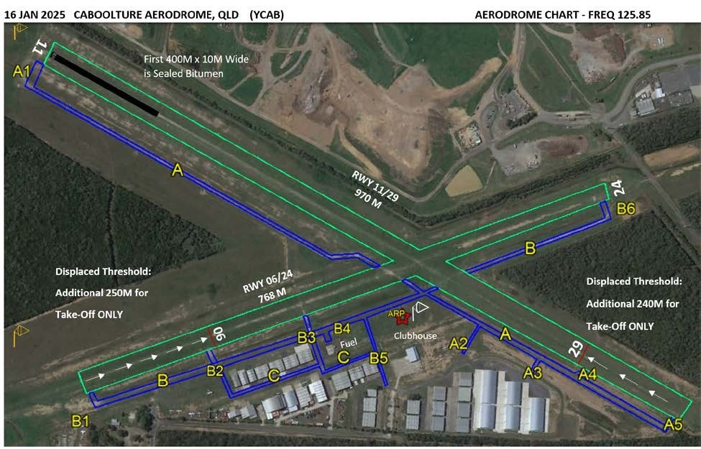
Airfield Administration & Contact Details
Name of aerodrome operator: Caboolture Aero Club Incorporated
Postal address: Lot 451 McNaught Road, Caboolture, Queensland 4500
Phone number: 0488 922 245
E-mail address: secretary@cacq.com.au
Website: www.cabooltureaeroclub.com.au
Airfield usage: Private & Public Use. Visitors welcome and public use
available with Prior Permission Required. (PPR)
YCAB IS ONLY TO BE USED DURING DAYLIGHT HOURS– CTAF FREQ 125.85 MHZ
Airfield Location
Aerodrome name: Caboolture Airfield
State/Territory: QLD
ARP latitude (WGS84): 270437S
ARP longitude (WGS84): 1525913E
Y location code: YCAB
Elevation: 40 ft.

SUMMARY OF SIGNIFICANT FLIGHT PROCEDURES

The following Rules are the most significant and important rules which if properly followed will provide the safest and consistent flying environment at Caboolture Airfield.
CASA Part 91 applies to all categories.

- Right Hand Circuits are required when operating Runway 29.
- NO Simultaneous Runway Operations are permitted under any circumstances.
- Under light or variable wind conditions, Runway 11 is the designated preferred runway due to Noise Abatement.

- The change of Active Runway Procedure;
Pilot requiring a change of runway due Crosswind or wind direction change, communicates by radio to ALL aircraft in the circuit or taxiing, and must receive confirmation or acknowledgement from ALL aircraft to accept the change. ALL aircraft in the circuit are allowed to complete the current circuit and land or depart the circuit. No aircraft are to take off prior to ALL aircraft in the circuit completing the landing and hearing a radio call of “Clear/Vacated” or “Departed the Circuit.”

- A “Rolling” call must be made at the commencement of take-off.
- Fly Neighbourly requires complete knowledge of Noise Sensitive Areas (NSA) and circuit procedures for Runways 29 and 24. Visiting pilots will be warned or banned if violation is repeated. (Refer ERSA)
- Intersection departures are NOT permitted for all aircraft types except helicopters. Helicopters must taxi to intersection and depart using active runway direction in use at all times.
- All aircraft including helicopters and rotorcraft to conform to standard circuit rules – AC 91- 10 applies.
- Straight-In Approaches are NOT Permitted on any Runway.
- Helicopters may operate to the side of all Runways, (outside gable markers) but where possible avoid centrelines due to damage to grass.
- An aircraft within the gable markers is deemed as occupying the runway strip.
- Helicopters are not to use sealed taxiway north of Hangars on Taxiway B; use the sides of Runway 06/24 instead.
- Helicopters not to taxi between hangars.
- See and Avoid Procedures and Situational Awareness require effective Position Reporting by all pilots on the ground and in the circuit. (91 MOS Table 21.04 through 21.07)
- Rules for Taking off and Landing procedures (CASR 91.370) must be adhered to.
- A maximum of five (5) aircraft conducting circuit training in the circuit at any one time.
- All surface vehicles (lights illuminated) are to make a Radio call prior to entering or crossing an Active Runway.
- No Land and Hold Short Operations (LAHSO) to be conducted at any time.
- Runway 24 not to be used, except for emergency or inclement weather – Left turn at 500 ft. AGL.

IF AN EMERGENCY OCCURS AT CABOOLTURE AIRFIELD, WHAT DO YOU DO?

CLUB PRESIDENT ONLY – IS AUTHORISED TO COMMUNICATE WITH MEDIA

ASSESS THE SITUATION – CHECK THE FOLLOWING DETAILS!

AIRCRAFT OR VEHICLE – NATURAL DISASTER – FIRE - UNLAWFUL ACTIVITY
CLEARLY IDENTIFY LOCATION
PERSONS INVOLVED - NUMBER - POSSIBLE INJURIES
HAZARDS – FIRE – CHEMICALS – BUILDING OR HANGAR INCIDENT
SAFE ACCESS TO INCIDENT – IDENTIFY EMERGENCY ASSEMBLY AREAS
SECURITY OF SITE

COMMUNICATE ASAP - CALL!

BUILDING - YELL OUT A WARNING TO EVACUATE - DO NOT LOCK DOORS
CALL 000 FOR ASSISTANCE – INCIDENT DETAILS - GIVE SITE ACCESS DETAILS
CALL CLUB EMERGENCY PHONE - 0488 922 245
FOLLOW INSTRUCTIONS FROM CLUB PRESIDENT, ARO OR TEAM LEADER

PROVIDE ASSISTANCE IF SAFE TO DO SO – CARE FOR INDIVIDUALS!

INJURIES - RENDER FIRST AID IF SAFE TO DO SO
USE FIRE EXTINGUISHER / FIRE HOSE
HAZARDS – CLEAR SAFETY DISTANCE/ENVIRONMENT – WAIT FOR EMERGENCY SERVICES
TEAM LEADER - FACILITATE & COORDINATE ACCESS FOR EMERGENCY SERVICES
CONFER WITH EMERGENCY SERVICES
DIRECT & SAFELY GUIDE SERVICES TO INCIDENT SITE – CHECK GROUND CONDITIONS
CLOSE THE SITE AIR OPERATIONS – REFUELLING OR MAINTENANCE- AS NEEDED
INSTALL X’S ON RUNWAYS & WINDSOCK CIRCLE - AS REQUIRED

COMMUNICATE – MONITOR ALL FLIGHT OPERATIONS – CTAF OR PHONE

APPOINT TASK PERSONS – SPECIFY DUTIES
MAINTAIN SITE SECURITY - CONTROL THE ACCESS GATES
ARRANGE FOR REPLACEMENT TASK PERSONS – IF LENGTHY INCIDENT RECOVERY

WHEN APPLICABLE, COMPLETE SITE RECOVERY OPERATIONS

CONFIRM SITE SERVICEABILITY
REOPEN THE AIRFIELD – FULL OR PARTIAL WHEN DEEMED SUITABLE
ONCE FULL RECOVERY OF AIRCRAFT OR VEHICLE OR HAZARD - COMPLETED
SITE INSPECTIONS HAVE BEEN COMPLETED – INCIDENT DETAILS RECORDED
SAFETY OF ALL CONDITIONS - DEEMED COMPLETED

POST INCIDENT REVIEW

TEAM LEADER TO CONVENE AT APPROPRIATE TIME – OFFSITE LOCATION
CHECK WITNESS STATEMENTS
DEBRIEF THOSE INVOLVED - INCLUDE EMERGENCY SERVICES

AERO CLUB MANAGEMENT COMMITTEE

REVIEW THE INCIDENT – EXPERIENCE GAINED – CONTACT AUTHORITIES IF
REQUIRED - REVISE & UPDATE EMERGENCY RESPONSE PLAN AS NEEDED

Runway bearing, length, width, and surface type
The bearings, length, width, and surface type(s) of the runway(s) is recorded in the table below:
Runway | Runway bearing (Magnetic) | Runway length (m) | Runway  width (m) | Runway surface type, or types (non-homogenous runways)
RWY 11/29 | 120/300 | 1210m  970m TODA | 8m | Grass. First 400m (8 m wide) of RWY 11 sealed Bitumen.
RWY 06/24 | 058/238 | 820m  768m TODA | 8m | Grass

Runway Pavement Strength rating
The runway(s) at Caboolture Airfield are natural surface runways without formed pavement except the first 400 m. of RWY 11 of sealed bitumen. A ‘Traffic Light’ system has been adopted and can be found on the club website. https://www.cabooltureaeroclub.com.au/runway-status/
The Airfield is limited to 5,700KG and below. Emergency Service Aircraft are Exempt.
Fuel Suppliers
Fuel suppliers and their contact details are recorded in the table below:
Fuel supplier | Fuel type | Contact details | After-hours contact details
VIVA: Unmanned  24HR Card Swipe Bowser | AVGAS | 0408 711 968 | N/A
Caboolture Aeroclub | MOGAS | 0488 922 245 | N/A

Location of Runway threshold/s
The following runway thresholds are permanently displaced from the extremity of the runway:
Runway end | Distance of threshold displacement | Reasons for permanent threshold displacement
RWY 06 | 250m - Permanent | Displaced due to Noise Abatement Procedures  Local Government Notice of Consent section  3(a)(i)
RWY 29 | 240m - temporary | Displaced due to Trees along boundary infringing on OLS on Eastern end

NOTE – Pilots must be aware that the trees located between Runway 11/29 and Runway 06/24 may obstruct their ability to observe traffic during take-off and landing at the airfield. Pilot should use adequate and sufficient communication in accordance with CAS AC 91-10 to ensure safety of operations. BE SEEN, BE HEARD, BE SAFE.

